**Lesson 07 Demo 5**

**Variables in Jinja2 filters**

**Objective:** To process variables in Jinja2 filters

**Prerequisites:** You need to have Python 2.7 or higher, Minimum 8 GB RAM, and SSH or SCP communicator.

**Tools Required:** Ansible and Jinja2

**Steps to be followed:**

1. Creating a playbook having **syntax** filters
2. Creating a playbook having **default** filters

**Step 1: Creating a playbook having syntax filters**

1. Create a playbook that will have a variable, **my_name,** and configure it using Jinja2 filters

**sudo nano jinja_template.yml**



**---**

**- name: Data Manipulation**

**hosts: localhost**

**gather_facts: false**

**vars:**

**my_name: Aniket jain**

**tasks:**

**- name: Print message**

**debug:**

**msg:**

**- "My name is {{ my_name }}"**

**- "My name is {{ my_name | lower }}"**

**- "My name is {{ my_name | upper }}"**

**- "My name is {{ my_name | capitalize }}"**

**- "My name is {{ my_name | title }}"**

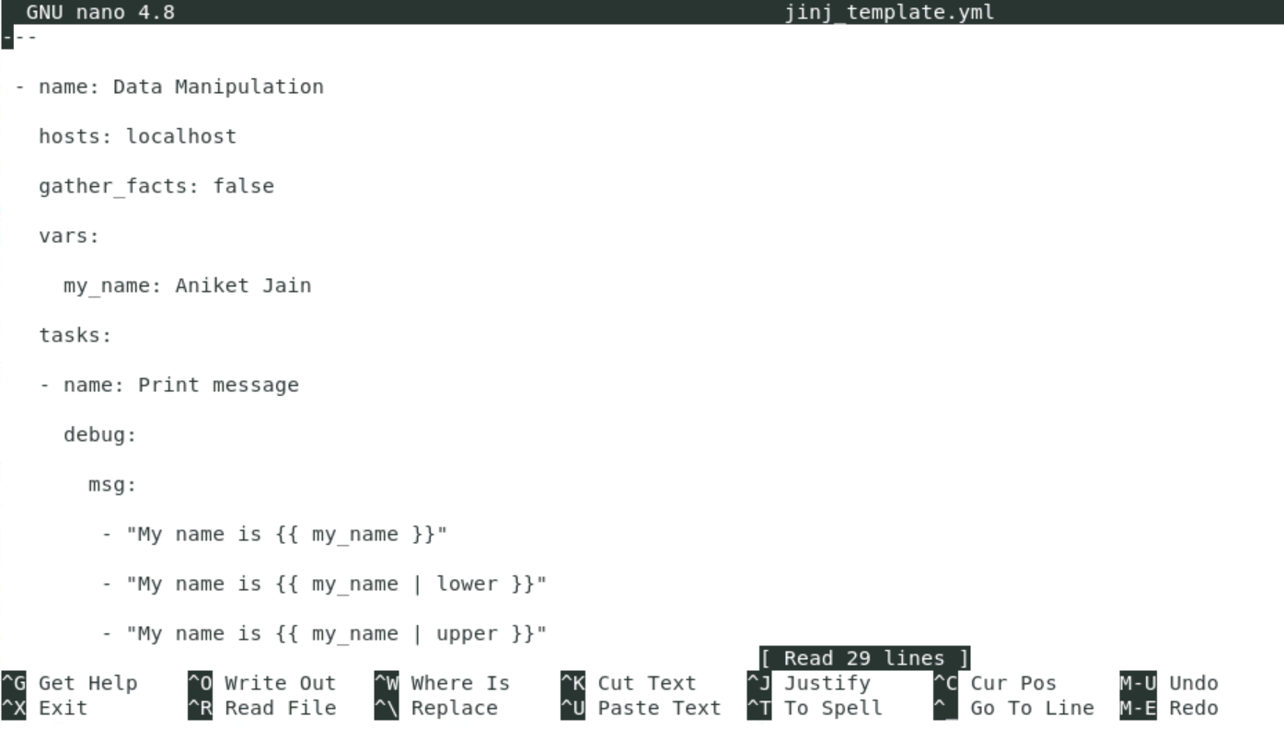

* 1. Run the playbook using the command below:

**ansible-playbook jinj_template.yml**

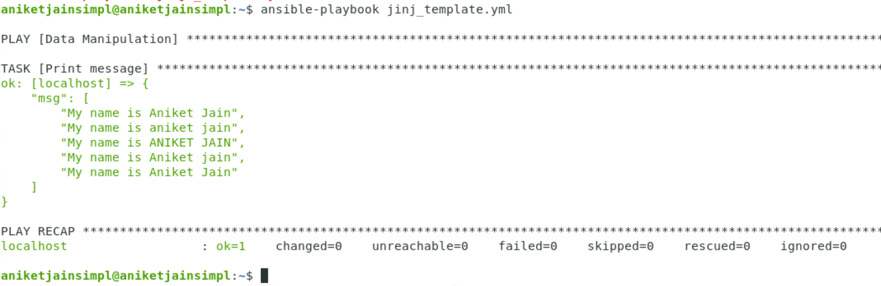

**Step 2: Creating a playbook having default filters**

* 1. Create a playbook that will have a variable, **first_name,** and configure it using default filters

**sudo nano jinj_default.yml**



**---**

**- name: Data Manipulation**

**hosts: localhost**

**gather_facts: false**

**vars:**

**first_name: Aniket**

**tasks:**

**- name: Print message**

**debug:**

**msg:**

**- "My name is {{ first_name }} {{ last_name | default('jain') }}"**

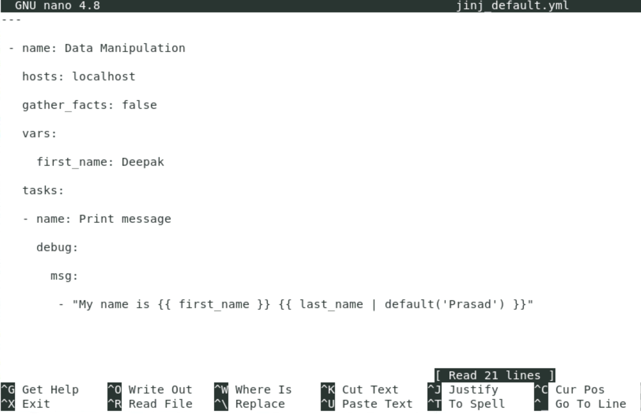

**Note:** If we don’t pass **default** for the last name, it will show an error.

* 1. Run the playbook using the command below:

**ansible-playbook jinj_default.yml**

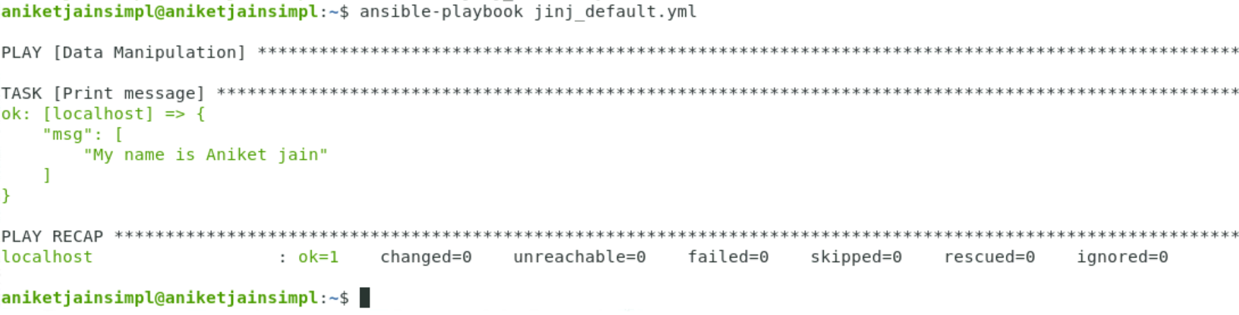

The playbook runs successfully even in the absence of the last name because of the **default** filter.